Welcome Back from Winter Holiday!
Teaching of the month is Wisdom – The bever brings the gift of Wisdom.

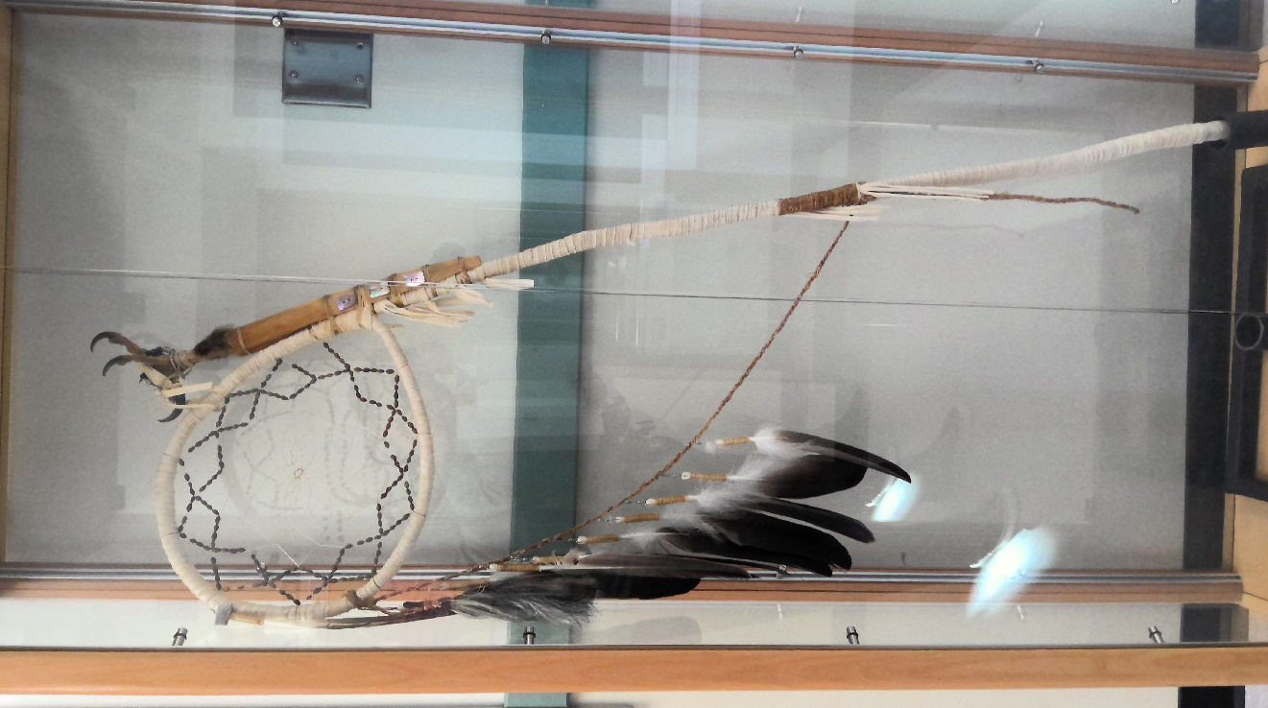

Our school is hosting the Education Pow Wow Performance this Year on January 29th.2026. We have a new display at our school for the Winter Celebration. Students are excited about the display and the pow wow coming up. The display will be with us for the year until the next school hosts the Winter Celebration.

