This month at CLC we have been busy. To honor out vets we visited the Shullus cenotaph where we looked at all the names of the indigenous vets who had served from our valley. We had read the syilx and nlakapmux prayer that is presented on the Plack in the front.
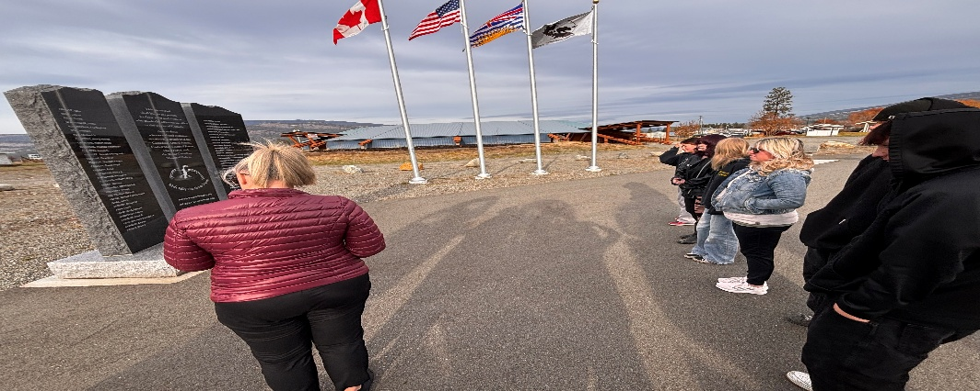
Students where excited to start our workshop of the month, feather beading. We started the project start to finish with our presenter Roipellst Joe. Roipellst is a young nlakapmux and syilx man from the valley who has been practicing beading for the last few years. Students practiced introducing themselves and their family, as we practiced traditional protocols of introduction.
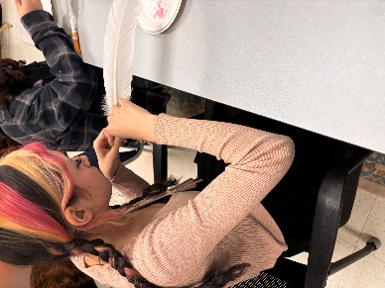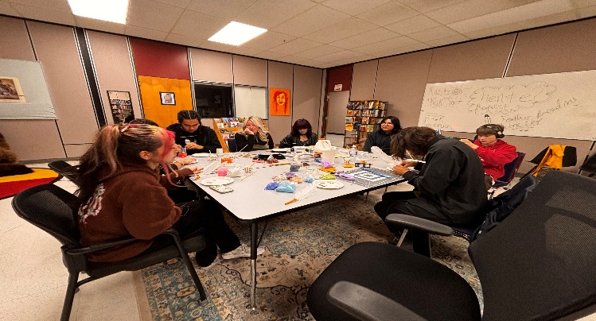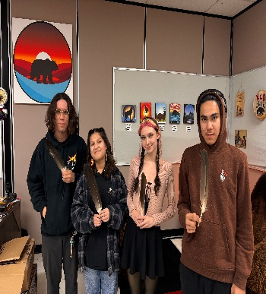

Students visited the BC wild life park, learning about local animals.
