Bench Report – ISW. Dec. 2025
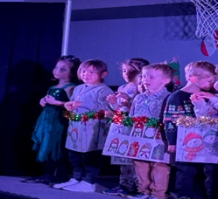
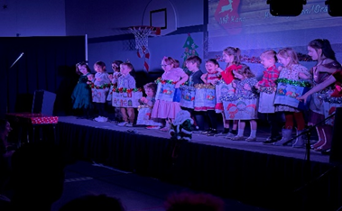
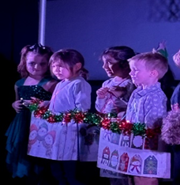
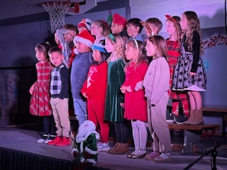
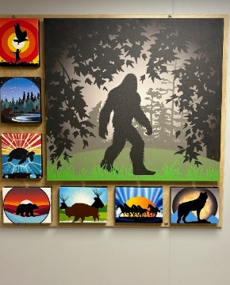
Powerpoint
- Eight Sacred Teachings
- Family Importance
Bench Xmas Concert: Dec. 18

\

Class Room Connections
- Hand Drumming
- Story Telling
- Medicine Pouch Making
- Family Importance
- Nɬeʔkepmux number counting
- Eight Sacred Teachings
- Nɬeʔkepmux animals
- Nɬleʔkepmux body parts
- Literacy every Tues. & Thurs.

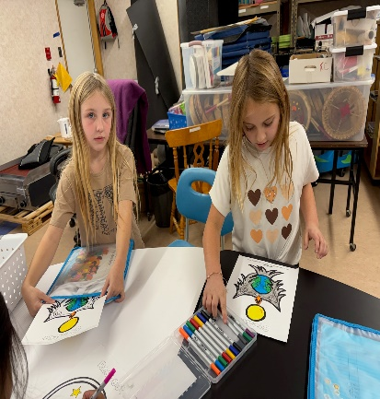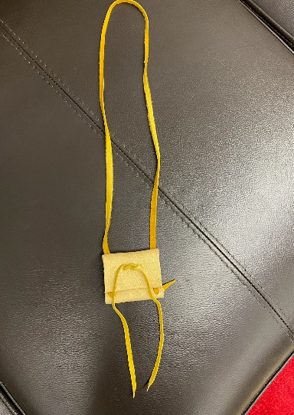
Grade 2 Class: Medicine Pouch Making – Dec. 19th

