
ISA TANYA EDWARDS
We are guest on the Nlaka’pamux and Syilx territory .
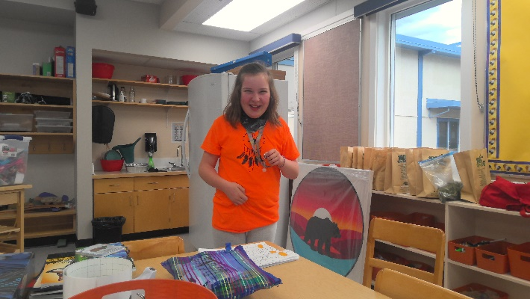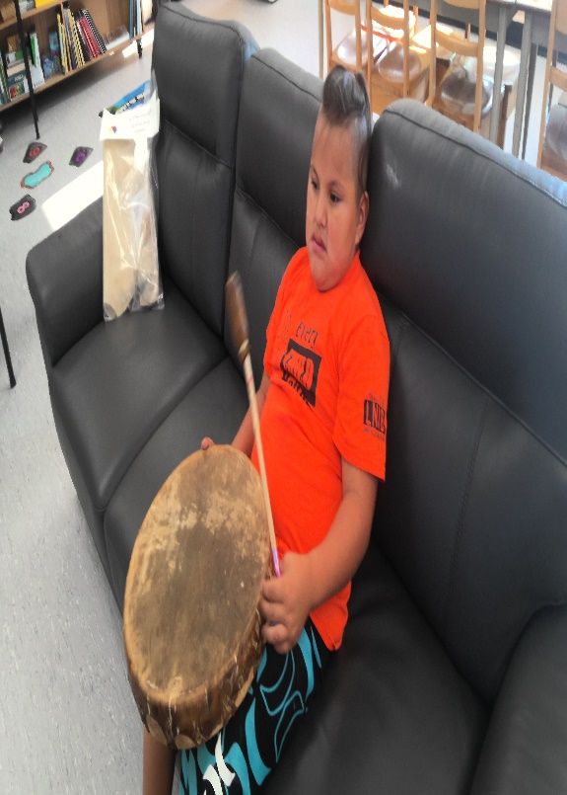
OCTOBER 2025
Meet and Greet every morning to the students. I will eaither greet outside or in the classrom visits and all the events. I am building a great communications with alll students here at DVE.
With alI students I talk about respect and communication is important. I do attend SBT,IEP when im invited. I have a great connections with all teachers and EA’s. Im in reading group with grade2’s 4 days a week. Talking tables with Kindergarten 2 times a week. I support grade 5/6 with Math 2 x a week.Kids are loving Nie?kepmxcin language class Kindergarten to Grade 7 students. I am currently assistaning coaching volleyball. 18 wonderful students signed up for it . They are amazing im very Proud. I also love being on the PAC team too. Been a amzing month of October 2025 . Thank You

