Community Learning Center (CLC)
This month at CLC was about creating student connections. As we fell into the season of fall, we learned about kećéʔ (laberdour tea) a treditional tea in the nłekepmx & syilx territories typically picked in the fall. We attempted to pick tea with guest Paul Joe but were quickly turned around, but still finding new ways to connect with our roots. Students played lahal, singing and drumming our songs. Then students cozied up on the couches and listened to captikw.
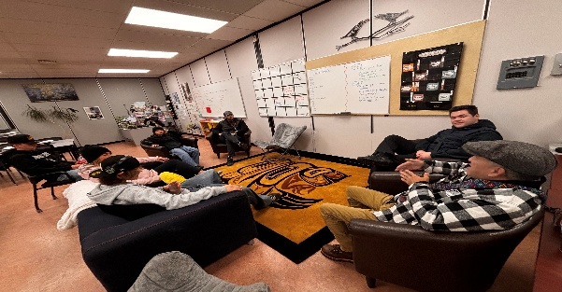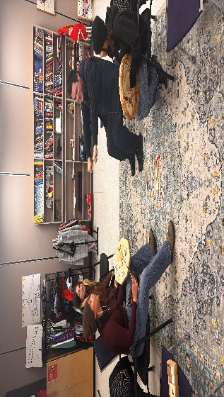

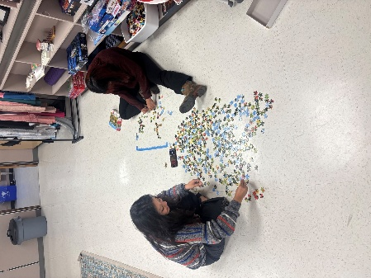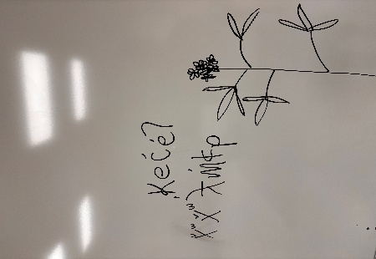
CLC has been working on incorporating more language wherever possible. Creating posters with QR codes to scan and hear the nsyilxcn.
